

May/June
20 | 21 | 22  Kindergarten  Round-Up @ 4:30—6:00pm | 23 | 24  WMMS Incoming 6th Grade Open House 6:30-8:00 pm | 25 | 26
27 | 28 No  School  Memorial Day | 29  Storytelling  Assemblies | 30 | 31 | June 1  PTO Movie Night Doors open at 5:30 | 2
3 | 4 | 5 | 6 Early  Release @  1:55 pm  PM Kinders stay all day | 7  Field Day | 8 | 9

The next school board meeting is Wednesday, June 13th @ 7:00 pm in Council Chambers at Fairview City Hall. Located at 1300 NE Village St. in Fairview. Call 503:661-7200 for more information.
Woodland Elementary School • 21607 NE Glisan • Fairview, OR 97024
Chris Greenhalgh, Principal • (503) 674-8188 • www.reynolds.k12.or.us/~woodland

May 18, 2012
Christopher Leebrick
Story Teller
Woodland’s PTO group is sponsoring two storytelling assemblies on Tuesday, May 29th. Christopher Leebrick engages audiences in a variety of multicultural tales. He does Appalachian folk tales, Native American legends, original stories and even Dr. Seuss. Students will witness storytelling, which is possibly the oldest art form in the world. The first assembly for K-2 will be from 9:30 – 10:15 am and 3rd-5th grades from 10:30-11:15 am. Thank you PTO!

Woodland Spirit Winners
Wednesday Wolf Spirit Winner for May 9th was Ms. Macdonald’s 4th grade class with 96%. On Wednesday, May 16th we had two classes with 100%, Ms. Anke and Ms. Kennedy’s third grade classes!

Order Yearbooks Now!!!
$10.00
Oleg’s Tree
On Friday, May 4th a special assembly and reception was held to honor Oleg Prystupa. He was a fourth grade student at Woodland who passed away last October 27th while visiting in the Ukraine. A white Dogwood tree was planted in our school garden and dedicated in memory of Oleg.



No School
Monday, May 28th
Memorial Day

April 8th Parent Group Meeting @ 4:30 pm

April 15th Wolf Council @ 1:50 pm

April 23rd Spring
Pictures

May 14th Kindergarten
Round-Up @ 4:00 pm

District News
Upcoming Events
Woodland Parent/Teacher
Organization (PTO)

Our next meeting is Monday, December 5th at 6:15 pm. Please join us and help plan our December movie night.

Penny Drive For
Special Olympics
Room 106 (Life Skills) is sponsoring a penny drive for the Special Olympics. Bring in your pennies, nickels, dimes and quarters between Jan. 17th—Feb. 8th. This is a fundraiser for the Polar Plunge where participants jump into the Columbia River on Saturday, Feb. 11th. Several of our staff members will be doing the “plunge”. Support the cause and bring in your spare change!

Penny Drive For
Special Olympics
Room 106 (Life Skills) is sponsoring a penny drive for the Special Olympics. Bring in your pennies, nickels, dimes and quarters between Jan. 17th—Feb. 8th. This is a fundraiser for the Polar Plunge where participants jump into the Columbia River on Saturday, Feb. 11th. Several of our staff members will be doing the “plunge”. Support the cause and bring in your spare change!
N

If your student(s) are going to be absent please call the school @ 503:674-8188. You may call the night before or early in the morning and leave a message. Please call by 9:00 am!

Early Release
The next early release date is Wednesday, June 6th. Students will be dismissed at 1:55 PM.
PM Kindergartners will attend all day.

AM Kinders will stay home.

Kindergarten Round Up
Tuesday, May 22nd from 4:30 to 6:00 pm is Woodland’s Kinder Round-Up. Remember in order to enroll for next fall’s kinder class the child must be 5 on or before September 1st, 2012. Other information needed at time of registration is a copy of a birth certificate, proof of immunizations and verification of address. Registration packets are available in the office.

Oregon’s Dairy Princess Visits Woodland
Woodland had a special visitor recently, Miss Kristen Kaste, Oregon’s 2012 Dairy Princess. All the second grade classrooms were able to listen to her tell about dairy farming, dairy agri-business and good nutrition.
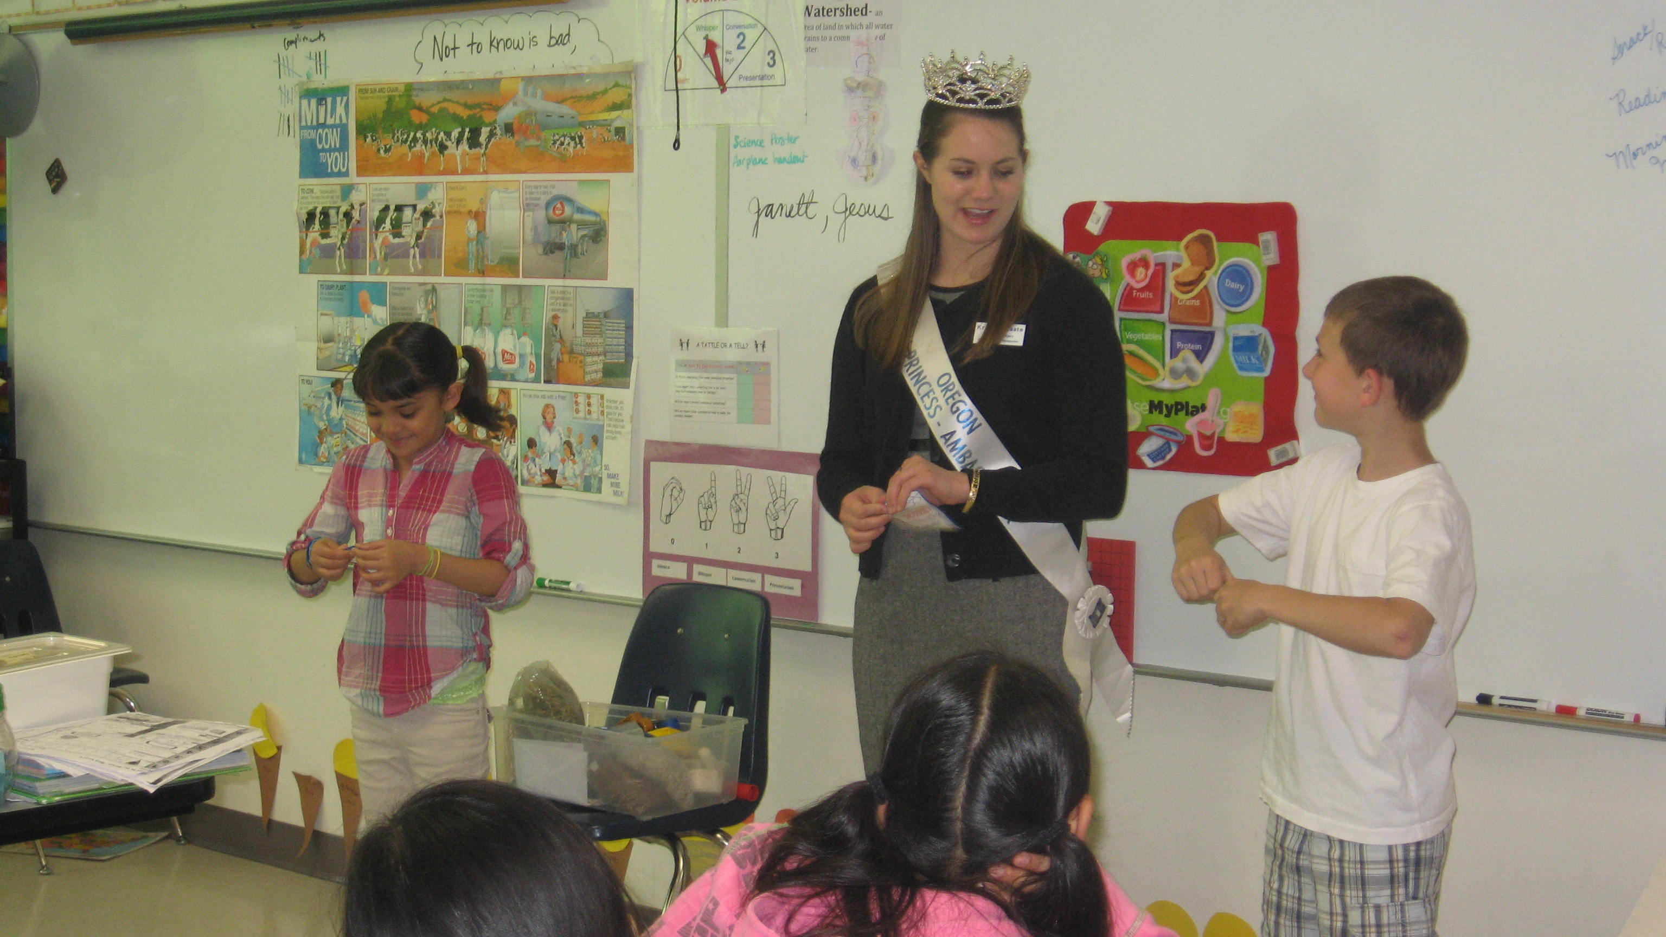nd nutrition.
Woodland Wanderings

Call In Absences
503:674-8188

Thank you Parent Group for our Field Trips
Woodland students have been able to go to Franz Bakery, Portland Youth Philharmonic Concert and even to the Zoo. The Parent Group donated funds for these field trips. Pictured below is Mrs. Westom’s second grade class at the Zoo on Thursday, May 10th.


Volunteer Tea
Postponed
The Volunteer Tea will be
re-scheduled. Details will be announced.

Parent Group Movie Night
Friday, June 1st
Doors open at 5:30 pm

Field Day, June 7th
If you can help with Field Day please contact our Parent Group Volunteer Coordinator, Karen LaVoie. The email address is:
WoodlandPTOGroup@gmail.com

Next Parent Group Meeting will be on Monday, June 4th at 6:15 pm. We will elect new officers for the 2012-13 school year.

Volunteer Update

