

Looking Ahead…December
4 | 5  Site Council @ 5:00  Parent Group Meeting at  6:15 pm | 6 | 7  Early Release  at 1:55 pm | 8 | 9  Hat Day | 10
11 | 12 | 13 | 14  MESD Health Screening | 15 | 16  Pop Corn  Sale 25 cents a bag | 17
18 | 19 | 20  PTO Movie Night @ 5:30pm | 21  Winter  Break  Begins | 22  Winter  Break | 23  Winter  Break | 24  Christmas  EVE
Woodland Elementary School • 21607 NE Glisan • Fairview, OR 97024
Chris Greenhalgh, Principal • (503) 674-8188 • www.reynolds.k12.or.us/~woodland

December 2, 2011

The next meeting is Wednesday, Dec. 14^{h} @ 7:00 pm in Council Chambers at Fairview City Hall. Located at 1300 NE Village St. in Fairview. Call 503:661-7200 for more information.
District News
Updated Web Site
A new updated website for Reynolds School District was launched on Friday, November 18th. Please go to
http://www.reynolds.k12.or.us to visit the new site. Click on schools and go to Woodland to view information about our school.

District –Wide Book Fair
Reynolds School District is sponsoring a district –wide Book Fair from December 1st to December 4th. Shop online at Barnes and Noble or attend special events at Lloyd Center Barnes and Noble Dec. 1st and 2nd from 5:30 to 7:30 pm and Dec. 3rd and 4th from noon to 5:00 pm. Teachers are making wish lists.

Woodland Mini- Grant Winners
The Reynolds Education Foundation awards mini-grants to district employees who write grants explaining what they would like to purchase for educational purposes. The following staff members were awarded funds: Tammy Dowden ($250.00), Glenda Douglass ($245.00), Erin Dugan ($161.00) and Janet Pardo ($150.00). Congratulations!
Woodland Wolf Wednesday Winners
Mrs. Dryer’s fourth grade class won the Wolf Pride Award on Wednesday, November 30th with 95% of the class wearing school colors!

Student Honors Bus Driver
Christina Miranda Tello, a fifth grader in Ms. Krell’s class, submitted an essay recognizing her bus driver, Skip Pillow. Thomas Built Bus Company sponsored a contest where children can write about their favorite bus driver. Christina read her winning essay at the RSD School Board meeting on November 9, 2011.
Mr. Pillow was one of five drivers recognized in the United States. Thanks to Christina for her efforts in writing the essay! Pictured below is Christina wearing her coat from Thomas Built Bus Company and her teacher, Ms. Krell.
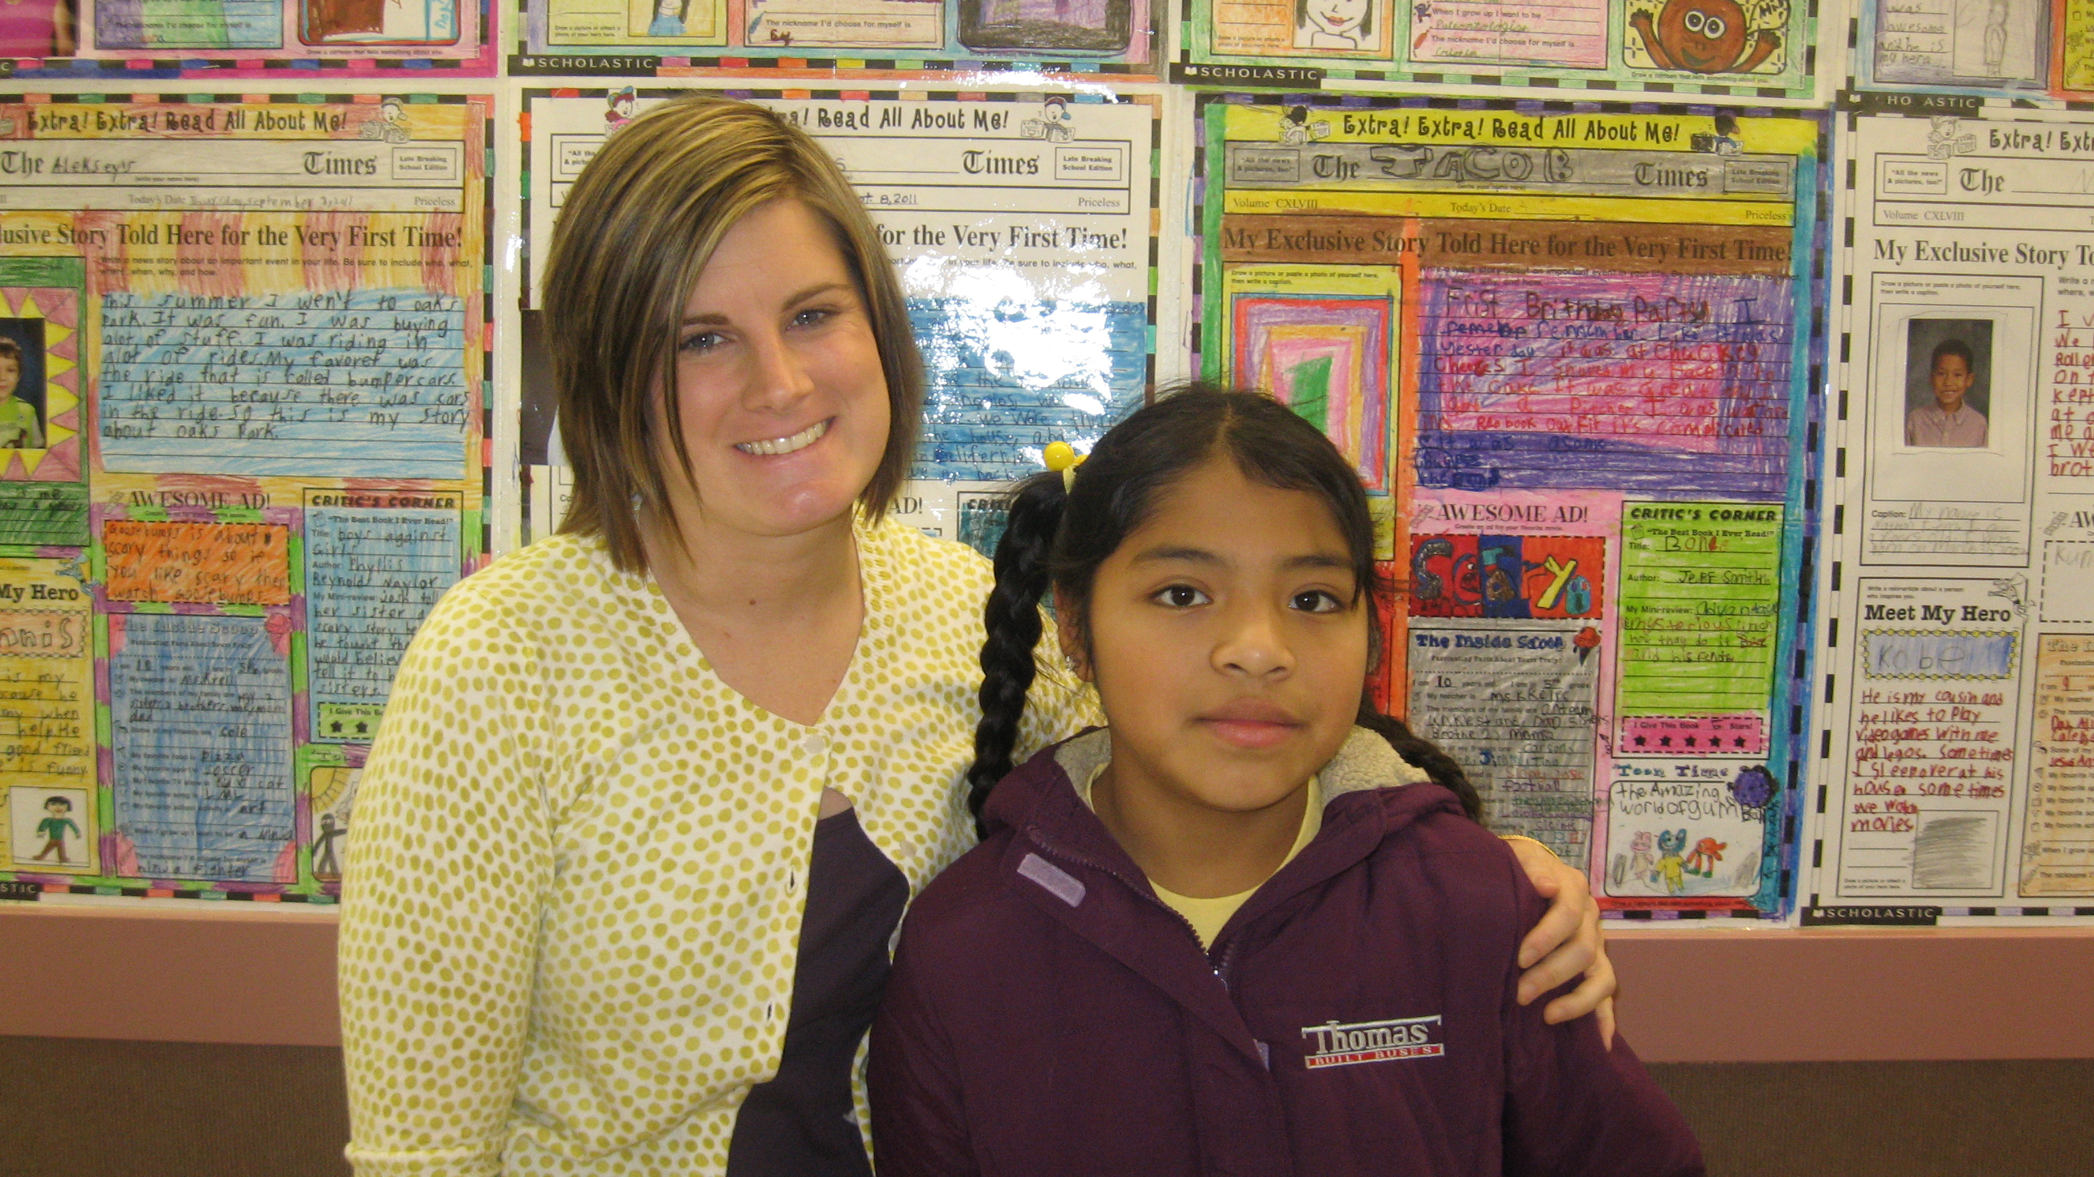

Parent Group Meeting @ 6:15
Monday, Dec. 5th

Pop Corn
Sale
Friday
Dec. 16th
25 cents a
bag

April 8th Parent Group Meeting @ 4:30 pm

April 15th Wolf Council @ 1:50 pm

April 23rd Spring
Pictures

May 14th Kindergarten
Round-Up @ 4:00 pm

Upcoming Events
Woodland Parent/Teacher
Organization (PTO)

Our next meeting is Monday, December 5th at 6:15 pm. Please join us and help plan our December movie night.

If your student(s) are going to be absent please call the school @ 503:674-8188. You may call the night before or early in the morning and leave a message. Please call by 9:00 am!

Early Release
The next early release date is Wednesday, December 7th. Students will be dismissed at 1:55 PM.
PM Kindergartners will attend all day.

AM Kinders will stay home.

BBook Worm Award Winners
On Wednesday, November 23rd, the following students were given certificates for being avid readers.

Kindergarten: Christine Nguyen, Ruslana Sharifova, Michelle Salas-Pizano,
Timothy Lukyan, Emma Tilden and Thomas Mitchell

First Grade: William Medina, America Vasquez Dominguez, Sage Vu, Kelsie Martinez-Zayas, Trinity Meeks-Scanlon, Dennis Lutsuk

Second Grade: Rianne Grotts, Timothy Polyak, Ester Leontyuk, Skylar
Arlindt, Milan Williamson

Third Grade: Rachel Tkachev, Stan Bogdanets, Claire Bouschor, Elijah
Carley, Tony Borisov, Aaron Torres

Fourth Grade: Khang Le, Diana Prychyna, Maria Hernandez-Angel, Andrea
Bautista-Angel

Fifth Grade: Jackson Arnold, Tyler Poulson, Alex Lutsuk, Codi Mead
Megan Convery, Estera Mitrik

Life Skills: David Cuy-Martinez, Venecia Hernandez, Cesar Pacheco Hagar Zubair

Woodland Wanderings

Call In Absences
503:674-8188

Positive Behavior Supports
At Woodland Elementary, students are rewarded for demonstrating positive behaviors that help create a respectful, responsible, and safe learning environment. The reward system currently has two levels.
The first level of reward is the Pack Power Ticket. Pack Powers are used to recognize students for simple everyday examples of following the rules. Students can use their Pack Power tickets to enter monthly raffle drawings for ice cream with the Principal, for classroom rewards, or to purchase Wolf Paws.
The second level is the Wolf Paw. Wolf Paws are rewards given to students for meeting school-wide expectations, i.e., making choices that demonstrate respectful, responsible and safe behavior. Wolf Paws can be used to purchase popcorn or to add to the Wolf Wall to help the school achieve school-wide celebrations.
Celebration! The students achieved enough wolves on the Wolf Wall this week to meet the mark for the first school-wide celebration!! So mark your calendars—Friday, December 9th will be Hat Day. All students will be allowed to wear hats in school all day. Thank you students. We are looking forward to celebrating with you. By: Marty Larsen, Counselor

Movie Night
Woodland’s PTO will be hosting it’s first ever movie night on Tuesday, December 20th. Kids will get to enjoy
watching “The Polar Express” in their pajamas during this fun family event. We will also have crafts available for those that wish to do them. Doors will open at 5:30 pm for seating and popcorn sales. The movie will start promptly at 6:00 pm. We will need volunteers for this event, if you are interested please contact Karen Lavoie at WoodlandPTOVolunteer@gmail.com. By: Anne Paskett, PTO President

Volunteer Update

