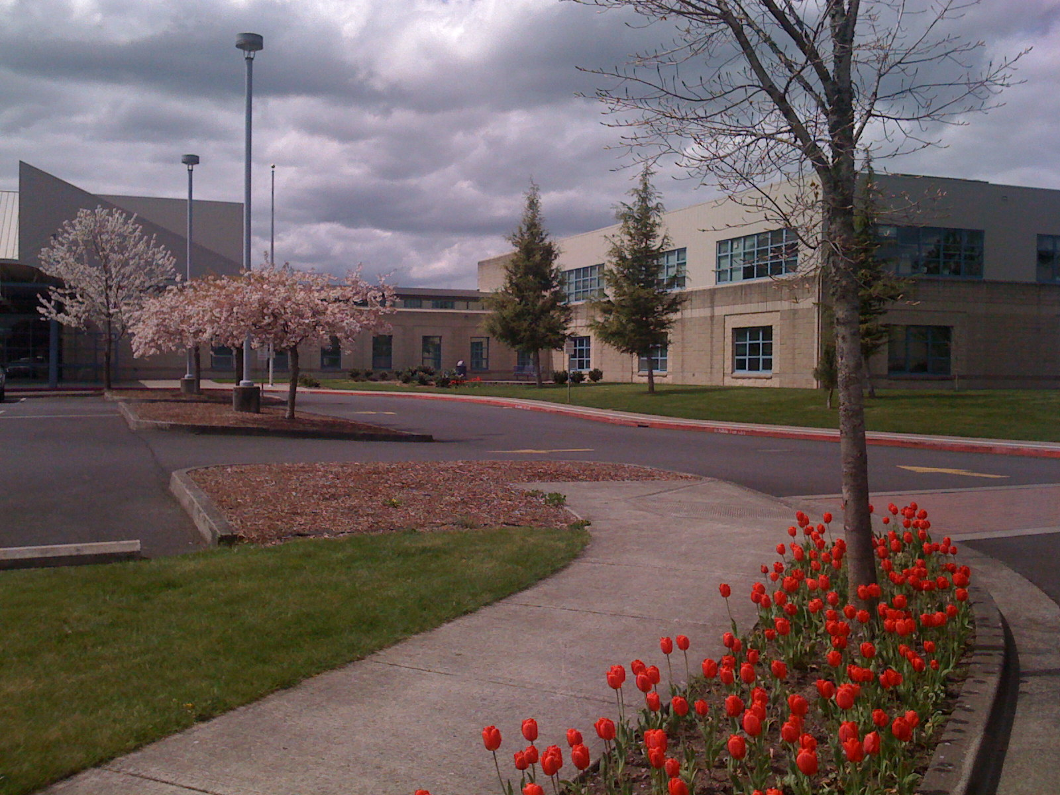

***May 25, 2017***

***6:00 to 7:30pm***

***2017 - 2018***

***6th Grade Open House***

**All parents and students of incoming 6th graders are invited to attend Walt Morey's annual 6th Grade Orientation on May 25th, 2017 at 6pm in the Main Gym.**

**Parents will be able to meet teachers, tour the school, receive information on curriculum, extra-curricular activities, and the transition from elementary to middle school.**

***WALT MOREY***

***MIDDLE SCHOOL***