November 2019 Newsletter
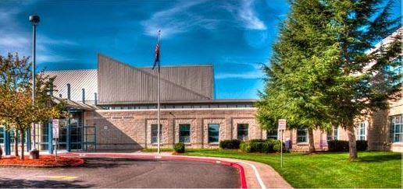
Walt Morey Middle School

Greetings Mustangs,
I want to begin by wishing you all a Happy Thanksgiving. During this busy time of year, I hope you find some time to relax with family and friends and enjoy the holiday season.
One of the things I am always most grateful for are the wonderful students who attend Walt Morey. It is such a privilege to watch them learn, grow, and develop through their middle school years. Whether I am talking to them in the hallway, laughing with them at lunch, looking over their shoulder in the classroom, or problem solving with them in the office, it is always a joy to know them, support them, and be a part of their lives.
As we go through the school year, there are many ways that we recognize and appreciate our students who continuously work hard. I am proud to announce that during the first quarter, we had 202 students who earned all As and Bs on their report card. These students were celebrated on Friday, November 13th, with a B’s or Better doughnut party. Additionally, 195 students had a 3.5 or better GPA, earning our prestigious honor roll recognition. Honor roll students will receive a certificate of accomplishment as well as a WMMS bumper sticker. To all of these students and their families, please know that the Walt Morey staff is very proud of your accomplishments!
Another way that we celebrate our students who make good choices is through our PBIS Activity Hour. The first of these events will take place on Friday December 20th, from 1:05-2:15. During Activity Hour, qualifying students may attend a dance in the gymnasium, which is DJ’d by our very own Zeek Goodrick! Or those who prefer not to dance can choose to participate in a number of other fun activities such as soccer, crafts, hand held games, and more. In order to earn the privilege of attending Activity Hour, students must have 90% attendance, passing grades in all classes (by December 13), zero out of school suspensions, and no more than one disciplinary referral. Please remind your students to come to school, get their missing work turned in, and make up any low test scores before December 13th, so that they are able to participate in the fun on December 20th.
Of course, our biggest celebrations of the year are the 8th Grade Recognition on June 8th and the 8th Grade End of Year Party on June 10th. These events are open to all 8th graders as we celebrate their promotion into high school. By tradition, these events are entirely parent planned and parent organized, so I am making my annual appeal to 8th grade parents. If you are willing to help, please come to the first meeting on Monday, December 2. We will meet in the library at 7:30. Hope to see you there!
Finally, if you happen to come to Walt Morey in the near future, you may notice a new face in our front office. I am thrilled to introduce our new attendance secretary Jennifer Feil. Jennifer is a former Walt Morey parent and staff member. Although she has spent the last 4 years working in the district office, we are so happy that she has finally decided to return home to her Mustang family! Next time you are in our building, please stop by her desk and say hello.
Again, have a wonderful Thanksgiving!
Sincerely,
Tanya Pruett- Principal

Boletín de Walt Morey – noviembre de 2019
Escuela Secundaria Walt Morey
Directora: Tanya Pruett Asistente a la Directora: Valorie Spearman
2801 SW Lucas Ave., Troutdale OR 97060
Oficina (503) 491-1935 Reportar Ausencias o Tardanzas (503) 661-9595
www.reynolds.k12.or.us/morey

Saludos Mustangs,
Quiero comenzar deseándoles a todos un Feliz Día de Acción de Gracias. Durante esta época ocupada del año, espero que encuentres algo de tiempo para relajarte con familiares y amigos y disfrutar de la temporada navideña.
Una de las cosas por las que siempre estoy más agradecida son los maravillosos estudiantes que asisten a Walt Morey. Es un privilegio verlos aprender, crecer y desarrollarse durante sus años de escuela intermedia. Ya sea que esté hablando con ellos en el pasillo, riéndome con ellos en el almuerzo, mirando por encima del hombro en el aula o resolviendo problemas con ellos en la oficina, siempre es un placer conocerlos, apoyarlos y ser parte de sus vidas.
A medida que avanzamos el año escolar, hay muchas maneras en que reconocemos y apreciamos a nuestros estudiantes que trabajan continuamente. Me enorgullece anunciar que durante el primer trimestre, tuvimos 202 estudiantes que obtuvieron A’s y B’s en su boleta de calificaciones. Estos estudiantes fueron celebrados el viernes 13 de noviembre con una fiesta llamada B’s or Better en donde comieron donuts. Además, 195 estudiantes tuvieron un promedio de calificaciones de 3.5 o más, obteniendo nuestro prestigioso reconocimiento en el cuadro de honor. Los estudiantes del cuadro de honor recibirán un certificado de logro, así como una pegatina para el parachoques de su carro. Para todos estos estudiantes y sus familias, ¡sepan que el personal de Walt Morey está muy orgulloso de sus logros!
Otra forma en que celebramos a nuestros estudiantes que toman buenas decisiones es a través de nuestra Hora de Actividad PBIS. El primero de estos eventos tendrá lugar el viernes 20 de diciembre, de 1:05- 2:15 pm. Durante la Hora de Actividad, los estudiantes que califican pueden asistir a un baile en el gimnasio, que es dirijido por el DJ de Zeke Goodrick. O aquellos que prefieren no bailar pueden optar por participar en otras actividades divertidas como fútbol, ​​manualidades, juegos y más. Para obtener el privilegio de asistir a Hora de Actividad, los estudiantes deben tener un 90% de asistencia, estar pasando todas las clases (antes del 13 de diciembre), ningunas suspensiones fuera de la escuela y no más de una referencia disciplinaria. Recuerde a sus alumnos que vengan a la escuela, que entreguen el trabajo que aun les faltan y que recuperen los puntajes bajos de los exámenes antes del 13 de diciembre, para que puedan participar en la diversión el 20 de diciembre.
Por supuesto, nuestras celebraciones más importantes del año son el Reconocimiento del 8º grado el 8 de junio y la Fiesta de fin de año del 8º grado el 10 de junio. Estos eventos están disponibles a todos los alumnos de 8º grado mientras celebramos su promoción a la escuela secundaria. Por tradición, estos eventos son completamente planeados por los padres y organizados por los padres, por lo que hago mi apelación anual a los padres de 8º grado. Si está dispuesto a ayudar, venga a la primera reunión el lunes 2 de diciembre. Nos reuniremos en la biblioteca a las 7:30. ¡Espero verte allí!
Finalmente, si viene a Walt Morey en el futuro cercano, puede notar una nueva cara en nuestra oficina. Estoy encantada de presentarles a nuestra nueva secretaria de asistencia, Jennifer Feil. Jennifer es una ex madre de Walt Morey y miembro del personal. ¡Aunque ha pasado los últimos 4 años trabajando en la oficina del distrito, estamos muy contentas de que finalmente haya decidido regresar a casa con su familia Mustang! La próxima vez que esté en nuestro edificio, pase por su escritorio y saludela.
Nuevamente, ¡tengan un maravilloso Día de Acción de Gracias!
Sinceramente, Tanya Pruett- Directora
NEWS AND ANNOUNCEMENTS
UPCOMING EVENTS

Every Wednesday: Wheel of Fortune during Lunches! One Mustang Buck to Spin and Win!

Nov. 28-29: No School: Thanksgiving Break
Dec. 2: PALS meeting/8th Gr Parent Mtg @ 6:30 p.m.
Dec. 4: Orchestra/Guitar Concert RHS 6:30pm
Dec. 10: Popcorn Tuesday
Dec. 13: 2nd Qtr Progress Report Period ends
Dec. 17: Progress Report Sent home
Dec. 18-20: Progress Reports Collected
Dec. 19: Ice Cream Thursday
Dec. 19: Fall SUN Ends
Dec. 20: Activity Day
Dec. 23- Jan. 3: No School-Winter Break
Jan 6: PALS meeting/8th Gr Parent Mtg @ 6:30 p.m.
Jan 14: Popcorn Tuesday
Jan 16: Ice Cream Thursday
Jan 28: Popcorn Tuesday
Jan 30: 2nd Qtr Ends
Jan 31: Grading Day – NO SCHOOL for students

Remember: Every Monday is late start! School starts at 8:40 a.m. on Mondays only. Tuesday-Friday we start at the scheduled time of 7:30 a.m. In order to be in class on time, it is recommended that students report to school 10 minutes early. School ends every day at 2:15 p.m.

Attendance Phone Number
503-661-9595
If your student will be late or will not be at school, please call before 8:00 a.m. Students are marked “unexcused” until we hear from a parent/guardian. When you call please leave the reason your student will be out; this helps us record the correct code in our software. You have 48 hours to excuse an absence. Thank you from the Attendance Office.

Reynolds School District School Board
The public is welcome at all School Board meetings. Meetings are held at 7:00 p.m. in the Multipurpose Room of Reynolds High School unless an alternate time or location is listed on the District website. RHS: 1698 SW Cherry Park Road, Troutdale, OR.
For a schedule of meetings and to view the agenda, please see
http://www.reynolds.k12.or.us/district/school-board-meetings
The School Board Liaison for WMMS is Diego Hernandez (dhernandez@rsd7.net) https://www.reynolds.k12.or.us/district/diego-hernandez-0

From PALS:
The staff of Walt Morey Middle School wishes to thank Manager Casey Gatto and the crew at Starbucks Coffee for supporting the staff by once again donating coffee. You are appreciated!
Hey there. It's time for PALS Winter Grams. You will be able to purchase a Winter Gram candy to be sent to a friend, a teacher, it even yourself. We will be doing the Grams Monday through Thursday, December 16 - 20. Come get yours at lunch time and they will be delivered during 7th period. Happy Holidays from PALS. Also, remember our fundraiser going on. The final turn in day will be December 3rd. Please make sure to bring in your fundraiser money so we can keep supporting our kids, teachers, and school. We love Walt Morey Middle School. PALS thanks you for all of your help and support.
Orchestra News:
On Wednesday, December 4, 2019, Walt MoreyOrchestra/Guitar Concert will take place in the Ben Brooks Auditorium, Performing Arts Building at Reynolds High School. The concert starts at 6:30pm. Guitar Students will be performing the Beatles tune, Eleanor Rigby with the Advanced Orchestra, as well as other pieces. In addition, all Walt Morey Orchestras will perform a wide variety of music. Come hear the fine musicians of Walt Morey on December 4th! This will be a fantastic concert!
Orchestra/Guitar students are selling World's Finest Chocolates until December 13th. Chocolate bars are $2.00, and make a great stocking stuffer or gift during the holiday season. Support Orchestra/Guitar students, and get your chocolate craving satisfied at the same time!

Congratulations to
Mustangs of the Month !
Each month students are nominated by teachers to be a Mustang of the Month. The following students have been selected to be a Mustang of the Month for November:
Ava Gray
Camella Walker
Tristan Baker Snelling
Emma Schlaht
Jasmine Saetern
Emily Carrillo
Le Daris Staples
Minh Tran
Kaitlyn Frick
Areli Sierra Gutierrez
Monthly winners receive a certificate, have their pictures posted in the entryway, and are invited to an exclusive pizza lunch with Mrs. Pruett.

Café News
Did you know . . .
. . . that our cafeteria offers breakfast EACH morning? . . . offerings include a hot item, bagels, a variety of cereals, string cheese, yogurt, fresh and canned fruit, and milk, apple and orange juice every morning?
And . . .
. . . that for lunch we offer 3 kinds of pizza, salads, sandwiches and wraps, and 2 different hot choices EVERY DAY?
. . . included are fresh fruits and vegetables of your student's choice plus chocolate or white milk?
Come see the ladies of the Cafeteria!
We are happy to serve you and answer any questions!

SUN Sports Success

We are very proud of our SUN sports teams! Our basketball team is coming off a two game win streak against Centenial and MLA charter (a 2 point nail biter!). They also played against Clear Creek and HB Lee, losing but learning a lot. As for our soccer team, commanding victories against Clear Creek, MLA, tie against HB Lee, losses against Centenial and Reynolds. We are looking forward to the district tournament December 6th, 10am-2pm at Reynolds Middle. Reynolds High coaches will be present and are excited to get a look at some of our players coming through the ranks.

Moving forward, our sports teams have proven to become popular with a lot of interest and demand from students. We will likely have tryouts next term, splitting into competitive and recreational teams so that students can access sports and grow as they want to. We hope our teams are a helpful training ground to build character, resilience, and healthy connections to the school and one another. We also hope to inspire some to play in high school and beyond, creating pathways to life-changing scholarships and healthy lifestyles.

Attention Parents of 8th Grade Students!
Please join us at our monthly meetings! The meetings are the first Monday of the month, following the PALS meetings, starting at 7:30. Help us plan the 8th Grade Recognition Event! If you have any questions, please attend the next meeting or email Stephanie Smith: craftysteff@gmail.com

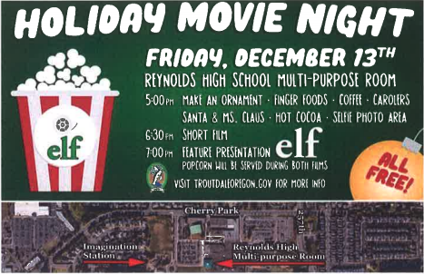

Reynolds School District Non-Discrimination Notice
Reynolds School District recognizes the diversity and worth of all individuals and groups in our society. It is the policy of the Reynolds School District Board of Education that all educational programs, activities and employment be free of discrimination or harassment of individuals or groups on the basis of race, color, religion, gender, gender identity, sexual orientation, national origin, disability, parental or marital status, or age.

Equal Opportunity, Title VII, American Disabilities Act and Title IX (staff): Jennifer Ellis, Executive Director of Human Capital Management at (503) 661-7200 x3418​
Title IX (students) and Section 504: Executive Director of Student & Family Services at (503) 661-7200
Title IX (athletics): Chris Coleman, Athletic Director (503) 667-3186 x1008

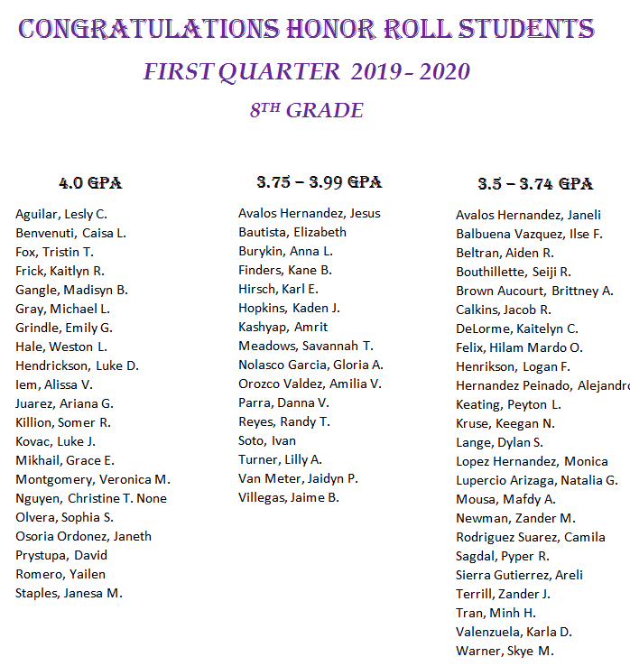
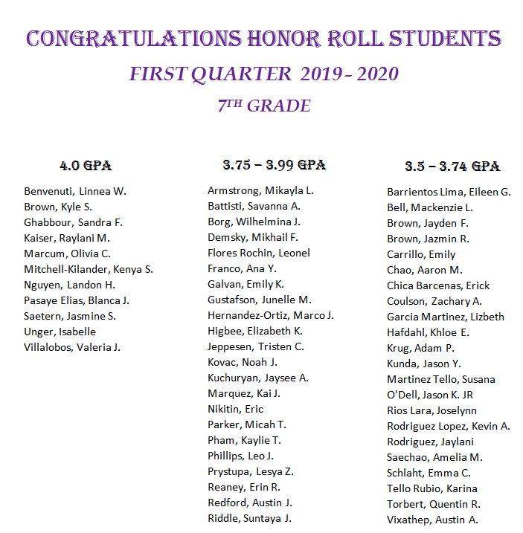
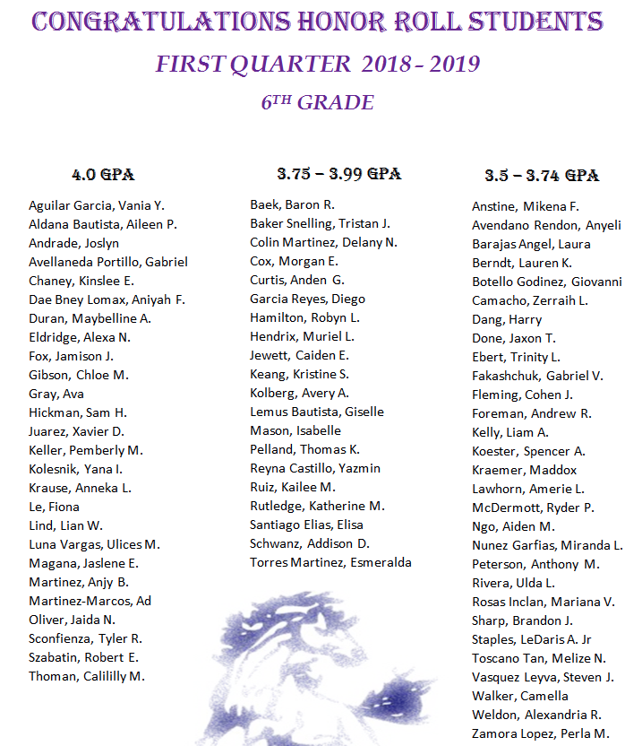

Holiday Food Donations Needed

We are preparing food boxes for WMMS families who are in need of extra food support in this holiday season. The SUN art class has decorated boxes that you can put your food donations into, the box can be found in the front office.

Below is a list of items we are in need of, we are hoping to fill 10 boxes for 10 families. Simply bring whatever you can from the list, in any quantity, any extras will be distributed to families. The counseling office, SUN, and other school staff have identified these families who are in significant need and are not otherwise receiving any support.

I would like to thank you in advance for your generous contributions on behalf of the most vulnerable families in our school community. We will be receiving donations until Friday, December 6th. Please reach out to Josh SUN manager (joshuag@irco.org) or counselor Karla (KWolf@rsd7.net) with any questions. Thank you all!

LIST OF ITEMS FOR EACH FAMILY BOX

___Box of oatmeal (not individual packs)
___Box of pancake mix
___Maple Syrup
___Box or can of hot cocoa (not individual packs)
___Box or bag of cereal
___2 Cans of tuna
___2 Boxes of mac and cheese
___Jar of peanut butter
___Jar of jelly or jam
___Box of top ramen (not individual packs)
___Box of crackers
___Bag of potatoes (5 lbs)
___Bag of rice
___Bag of dry beans
___Bag or box of pasta
___Jar or can of pasta sauce
___2 Canned Ravioli
___2 Canned Chili
___2 Canned Soup
___2 Canned Refried beans
___4 Canned Vegetables
___2 Canned Fruit
___Box of fruit snacks (not individual packs)
___Box of granola bars (not individual packs)
___Box of cheese/peanut butter crackers (not individual packs)

