Walt Morey Middle School
Basketball Schedule 2023
7th Grade plays at 4:45 pm; 8th Grade plays at 6 pm
Coaches: 8th – Jeff Thompson
7th – Naomi Corbett

Date | Opponent | Site | Bus
Monday, Feb. 5th | Clear Creek | Clear Creek | 4:00
Wednesday, Feb. 7th | Gordon Russell | Walt Morey
Monday, Feb. 12th | Ron Russell | Walt Morey
Wednesday, Feb. 14th | Oliver | Walt Morey
Wednesday, Feb. 21st | Alice Ott | Alice Ott | 3:45
Thursday, Feb. 22nd | Centennial | Centennial MS | 4:00
Monday, Feb. 26th | West Orient | West Orient | 4:00
Wednesday, Feb. 28th | Floyd Light | Walt Morey
Monday, Mar. 4th | Dexter McCarty | Dexter McCarty | 4:00
Wednesday, Mar. 6th | Reynolds MS | Walt Morey
Monday, Mar. 11th | HB Lee | HB Lee | 4:00
Wednesday, Mar. 13th | Parkrose | Walt Morey
*Buses will provide transportation to and from away sites

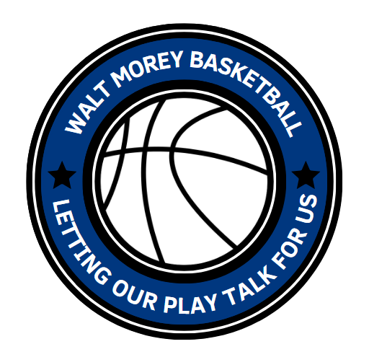
Alice Ott Middle School Centennial Middle School
12500 SE Ramona Street 17650 SE Brooklyn Street
Portland, OR 97236 Portland, OR 97236

Clear Creek Middle School Dexter McCarty Middle School
219 NE 219th Ave 1400 SE 5th St.
Gresham, OR 97030 Gresham, OR 97080

HB Lee Middle School West Orient Middle School
1121 NE 172st Ave 29805 SE Orient Drive
Portland, OR 97230 Gresham, OR 97080

