

Walt Morey Middle School
Basketball Schedule 2025-2026
7th Grade plays at 4:45 pm in 2025
8th Grade plays at 6 pm in 2025
Game times switch in Jan. 2026

Coaches: 8th – Jeff Thompson
7th – Brandon Stephens

Date | Opponent | Site | Bus
Tuesday, Dec. 2nd | Alice Ott | Alice Ott | 3:45
Thursday, Dec. 4th | Damascus | Walt Morey
Monday, Dec. 8th | Parkrose | Parkrose | 3:45
Wednesday, Dec. 10th | Dexter McCarty | Walt Morey
Monday, Dec. 15th | West Orient | West Orient | 3:45
Wednesday, Dec. 17th | Floyd Light | Walt Morey
*Wednesday, Jan. 7th | Clear Creek | Walt Morey
*Thursday, Jan. 8th | HB Lee | Walt Morey
*Monday, Jan. 12th | Reynolds | Reynolds | 4:00
*Wednesday, Jan. 14th | Ron Russell | Ron Russell | 3:45
*Wednesday, Jan. 21st | TBA | TBA | 3:45
*Thursday, Jan. 22nd | TBA | TBA | 3:45
*8th Grade plays first, 4:45 7th Grade plays second 6:00
Buses will be provided to and from game sites

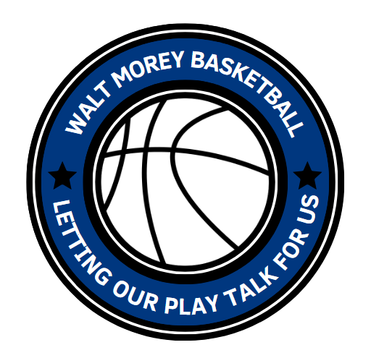
Alice Ott Middle School Gordon West Orient Middle School
12500 SE Ramona St 29805 SE Orient Drive
Portland, OR 97236 Gresham, OR 97080

Oliver Middle school Parkrose Middle School
15840 SE Taylor St. 11800 NE Shaver St.
Portland, OR 97233 Portland, OR 97220

Reynolds Middle School Ron Russell Middle School
1200 NE 201st Ave 3955 SE 112th Ave
Fairview, OR 97024 Portland, OR 97266

