Walt Morey Middle School
Basketball Schedule 2023
7th Grade play at 4:45 pm; 8th Grade plays at 6 pm
Coaches: 8th – Ed Miller
7th – Jeff Thompson

Date | Opponent | Site | Bus
Tuesday, Nov. 28th | Ron Russell | Ron Russell | 3:45
Thursday, Nov. 30th | Alice Ott | Walt Morey
Monday, Dec. 4th | Clear Creek | Walt Morey
Wednesday, Dec. 6th | Dexter McCarty | Walt Morey
Monday, Dec. 11th | Parkrose MS | Parkrose MS | 3:45
Wednesday, Dec. 13th | Centennial MS | Walt Morey
Wednesday, Jan. 3rd | Gordon Russell | Gordon Russell | 4:00
Thursday, Jan. 4th | HB Lee | Walt Morey
Monday, Jan. 8th | Oliver MS | Oliver MS | 4:00
Wednesday, Jan. 10th | Reynolds MS | Reynold MS | 4:00
Wednesday, Jan. 17th | Floyd Light | Floyd Light | 3:45
Thursday, Jan. 18th | West Orient | Walt Morey
*Buses will provide transportation to and from away sites

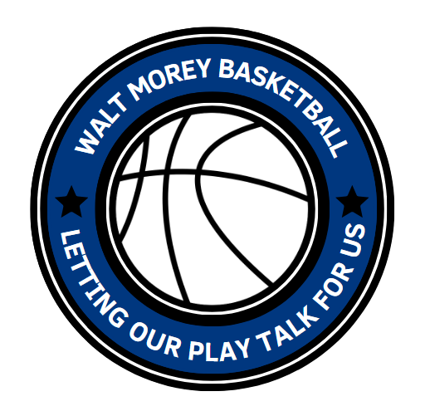
Floyd Light Middle School Gordon Russell Middle School
10800 SE Washington Street 3625 SE Powell Valley Road
Portland, OR 97216 Gresham, OR 97080

Oliver Middle school Parkrose Middle School
15840 SE Taylor St. 11800 NE Shaver St.
Portland, OR 97233 Portland, OR 97220

Reynolds Middle School Ron Russell Middle School
1200 NE 201st Ave 3955 SE 112th Ave
Fairview, OR 97024 Portland, OR 97266

