Attendance Matters

at Troutdale

*We* ***love*** *having your student at school!*

# What is good attendance?

* Going to school at least 90% of the time, which means missing **no more than 9 days for an entire year,** or about **1 day per month**.
* Missing **two days or more per month** is known as chronic absenteeism.
* We know that there are life factors including illness and family emergencies that cause students to be absent. When possible, it’s helpful to schedule **appointments and celebrations** outside of school hours.

# Why is attendance important?

* Students who regularly attend school are able to take advantage of classroom learning that will allow them to **read proficiently, develop math skills, and make friendships.**
* Missing 10 percent school can make it **harder** to learn to read.
* By 6th grade, chronic absence is a big indicator that a student will drop out of high school.
* Students who attend school regularly **feel better** about themselves and school.

# Tardiness (getting to school late)

* Bringing kids to school late is better than never! We know that unexpected things happen in the morning. Troutdale will **always** be happy to see you, whenever you are able to arrive.
* Chronic tardiness can be difficult for kids. In the morning at Troutdale, calm music plays throughout the school, students gather together for **Community Circles** and class meetings where they share stories, hear about the day ahead and work on making those social connections with peers. Coming on time allows students to settle into the day and into the classroom community, resulting in **stronger learning** and **more positive behavior.**

# How much sleep does my student need?

**When kids are too tired, they get sick more often and miss school.** Sleep affects a student’s health, growth, attention, learning, and emotions/mood. Getting enough sleep gives your child the best chance to do well at school!

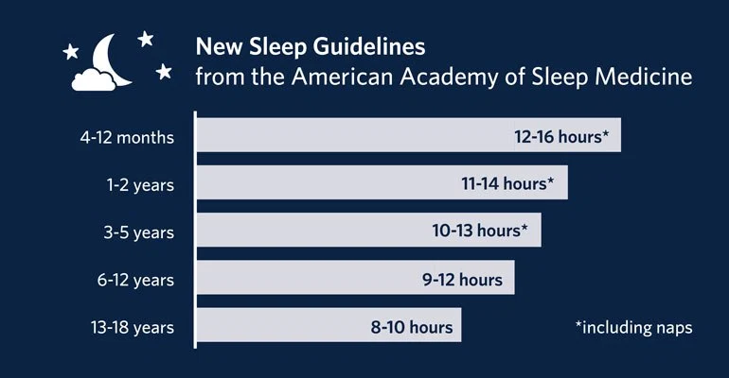

*For example, if your 8-year-old child* ***wakes up at 6:30AM*** *to get ready to be at school by 7:40AM, an* ***8:00PM bedtime*** *gives them 10 ½ hours of sleep – that’s within the recommended guidelines above!*

* Creating a bedtime routine helps children get used to going to bed early.

**The 4 B's of a bedtime routine: Bathing, Brushing teeth, Books, and Bedtime**It can also be helpful to keep bedtime and wake-up times roughly the same (within an hour or so) each day, even on weekends.

* **Kids at Troutdale** have shared these top reasons for staying up late and being tired (aka in the “Blue Zone”) at school: **Electronics, TV, and noises at night**.
* As much as kids might argue, removing electronics before bedtime can help them get a great night’s sleep!

# When should my student stay home?

|  |  |
| --- | --- |
| Fever greater than 100.4° (Your child should be fever-free for 24 hours without the use of a fever-reducing medication) | Vomiting |
| Rash or rash with fever – new or sudden onset | Diarrhea: 3 loose or watery stools in one day |
| Colored drainage from eyes (“pink eye” or conjunctivitis) | Cough: Deep, barking, or colored mucus |

***Please always call the office to let us know when your child will miss a day: 503-665-4182***

*If you have any questions or need assistance with food, transportation,*

*or other things related to school, we are here to help:*

Your Child’s Teacher: __________________________, ext. ______

Ed Krankowski, Principal: ext. 2211; (or Krista Woolsey, Mr. K’s secretary, ext. 2201)

Carrie Jordas, Attendance Secretary: ext. 2202

Cate Morris, School Counselor: ext. 2214