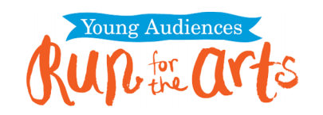

The Young Audiences-Run for the Arts program is happening at Sweetbriar Thursday, October 10th! The Run funds a variety of art programs to be enjoyed here at Sweetbriar. Sponsor forms went home Monday, September 23rd.

Students have the option to raise money for this program by collecting either a flat amount, or a per lap (a lap is considered 1/4 mile, our track is 1/8 of a mile) amount from sponsors. Students that raise $20.00 or more will receive a Run for the Arts T-shirt (sizes run small). Checks need to be written to Young Audiences or Run for the Arts. It is a fully tax deductable donation.

Please turn in the forms and money (unless it is a per lap amount) to the school office by the day before the run, October 9th. If it is a per lap pledge, pledge sheets will be given back to students after the run and they have until October 22nd to collect/turn in all donations.

