Halloween at Salish

Go Home First
Please remind your kids that when they leave school their first job is to check in at home. That way everyone knows they are safe.

On Time and Ready to Learn
Mondays: Doors open at 9:45
Class starts at 10 AM
Tuesday- Friday: Doors open at 8:35 AM
Class starts at 8:50 AM
Studies show that students who are on time to school are more likely to read on grade level, get better test scores and graduate at a higher rate. School doors open at 8:35 AM, and learning starts at 8:45 AM so help us get your students day stated by having them in their seats and ready to learn by 8:45.

Salish Ponds is a Title School
Salish Ponds receives federal funding that allows us to access resources to assist students in need. This year we are focusing our funds on reading. If you want to know more about our title program, please talk with an administrator.

Dragonfly News
Halloween is just around the corner, and we wanted to remind you that Salish Ponds is a no candy, no costume school every day, but specifically before Halloween.
Instead on Monday October 31st we encourage students to wear their Salish colors of green, white, purple, and black to school or to rock their favorite Salish Ponds shirt. Go Dragonflies!

Rainy and Cold Recess
Fall is here and winter is just around the corner. At Salish Ponds we will have the kids go outside rain or shine. With that in mind we ask that you help you child come to school prepared to be outside every day. Coats, hats, and gloves can help to make a cold day outside a fun recess for all.

Counselor Corner
Meet your School Counselors!

Hi everyone! My name is Arianne Delos Reyes and this is my second year as a school counselor and working at Salish Ponds! This year, I will be supporting primarily K-2nd grade students. Previously, I worked at an elementary school in Washington and moved to Portland just last year! In my free time, I love listening to music, watching movies, and hanging out with my cat, Dolly!

I’m Virginia Rose. I’m in my fourteenth year as a School Counselor and first year at Salish Ponds. I am mainly working with the 3rd-5th grade students. I’ve worked in small, rural schools where the entire district had less than 100 students and just finished working at David Douglas High School with over 2,800 students. I love working on my 1886 Victorian house, gardening, reading, and watching old films. I’m so happy to be working with your children at Salish Ponds.
We’ll be starting Lunch Bunch during Lunch/Recess. Lunch Bunch is when your child gets to pick a friend to come and have lunch with the counselor to play games and build relationships with peers while working on strengthening social skills. Lunch Bunch typically meets once per week.

Classroom Lessons are another service that we provide. We will be going into each classroom and delivering lessons on any number of topics that may include bullying prevention, kindness, and empathy.

Upcoming events
- October 6th school assembly on Kindness and
- October 7th- no school, State In-service
- October 11th- Timber Joey Assembly
- October 13th Picture Day
- October 31st school colors day wear your Salish Ponds shirts and colors.
Some resources on Empathy:
- A Kids book to Empathy
- Empathy Song
- Sesame Street: Mark Ruffalo: Empathy

Empathy Salish Ponds is a Title School
Salish Ponds receives federal funding that allows us to access resources to assist students in need. This year we are focusing our funds on reading. If you want to know more about our title program, please talk with an administrator.
Mrs. Rebecca Jones-Stevens
503-492-7260
rjones@rsd7.net
Salish Ponds Elementary Home Reynolds School District - Oregon

Salish Ponds PBIS Focus for October: Bully Prevention and Empathy
October is Bullying Prevention Month. Bullying Prevention Day is October 12th. This might be a good day to talk to your child(ren) about what bullying is and how harmful it can be. We are already dealing with the consequences of several incidents of bullying. If you need more information about bullying prevention, please see National Bullying Prevention Month | Youth.gov or NATIONAL STOP BULLYING DAY - October 12, 2022 - National Today or contact us at 503-492-7260 x 3016 (Arianne) or x 3037 (Virginia).

Salish Ponds Celebrates our Custodians
In honor of National Custodian Day on October 2nd, we want to give a shout out to our hardworking custodians, Mr. Stan and Mr. Jesse. They make sure our school is safe, welcoming, clean, and ready for students and staff each day! Thank you both!
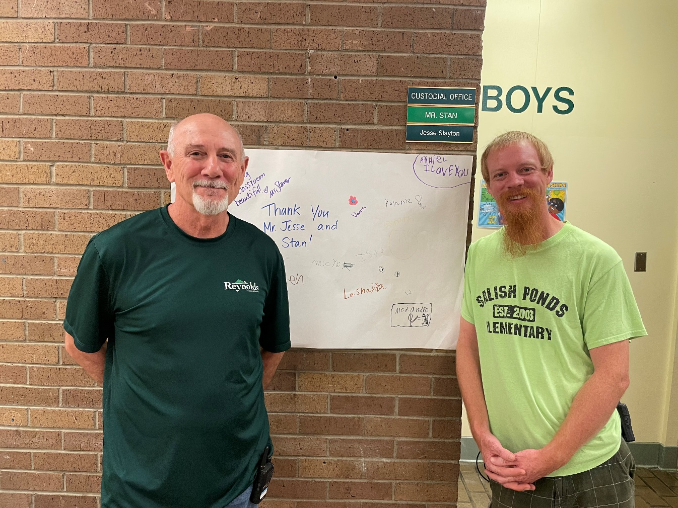

Salish Ponds on social media
We are working at Salish Ponds to have more information online for you to access. We are working on rules videos, nighttime stories, and other videos to post on our website for you. We are posting upcoming events on our website, Facebook, and Parent Square, and using our Parent Square to announce last minute things that come up like late busses. We hope you can find and follow us to help us improve our communication with your family. You can find us by searching Salish Ponds Elementary School on Facebook.

