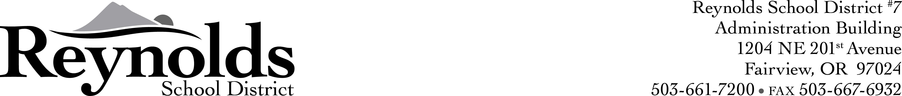

October 30, 2012

Dear Parent or Guardian,

We are writing this letter to ask your permission in advance to re-test your student in the spring of 2013, if they meet or exceed OAKS scores in the fall of 2012.

As of January 2012, the Oregon Department of Education no longer permits school districts to re-test students in grades 3 – 8 who have already met or exceeded the state achievement standard on the statewide Oregon Assessment of Knowledge and Skills (OAKS) unless the student’s parent or guardian permits the school district to retest their child.

The reason we would like to test again is to help each student demonstrate the highest achievement possible, and in turn, make evident more student academic growth.

Please sign, date and return the attachment to school, if you will allow your child to test a second time this spring, even if they met or exceeded testing in the fall testing round.

Thank you,

Barbara Casey Stacy Talus

Testing Coordinator Principal


CUT AND RETURN TO THE SCHOOL OFFICE
I give consent that my son/daughter, ______________________________________________,
(Student Name)
be administered additional OAKS testing opportunities in a content area where he or she meets or exceeds the achievement standard in that content area.

Print Parent Name:

Parent Signature:

Date:

School: Reynolds Middle School

(SCHOOL OFFICE STAFF: Return to School Test Coordinator)

