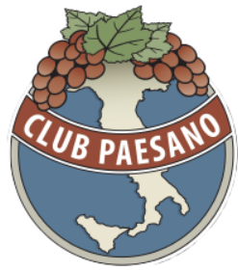
Club Paesano Italian American Scholarship

This is a new scholarship opportunity for high school seniors and freshmen in college who demonstrate a desire to learn and emulate Italian American attributes such as diligence and determination.

Paesano Bocce Club Application Form

Print the paper application from website or pick one up from the College & Career Center.

https://ClubPaesano.org

Deadline: Friday, May 10th, 2024
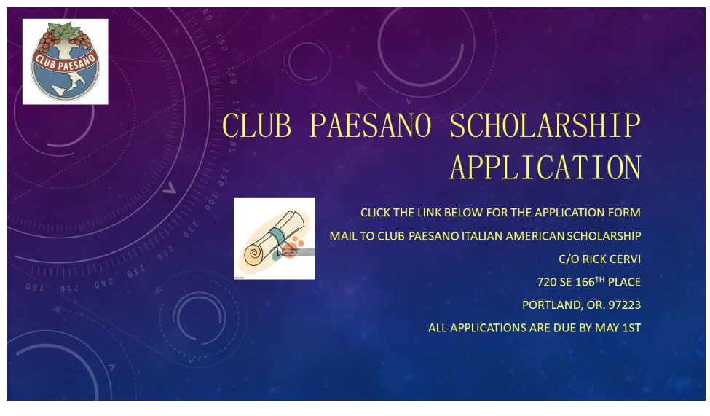

Eligibility Requirements:
- Be an incoming college freshman and current college freshman who resides in the Greater Portland Metropolitan area or Southwest Washington;
- Be accepted to an accredited institution of higher learning (including universities, colleges, community colleges and trade schools);
- A United States citizen or permanent resident alien;
- Have a minimum cumulative GPA of 3.0 out of a 4.0 scale; An official transcript must be submitted;
- Complete and submit application and forms by the applicable deadline;
- Be of Italian American descent with at least one ancestor that can be certified to have emigrated from Italy.
- Submit two letters of recommendation from teachers, coaches, a professors, employers or service coordinators.
- Submit a current resume outlining extracurricular activities, work experience and volunteer services.
- Submit an essay which must not exceed 750 words

Mail applications & all required documents to:
Club Paesano
Attn: Rick Cervi
720 SE 166th Place
Portland, Oregon. 97233
Email: rchabs23@hotmail.com

Recipients will be notified by May 25, 2024. The scholarship will be awarded on June 5, 2024 at Club Paesano/Cedarville Park at the Polenta dinner. This is a one-time award and must be collected for the 2024 fall semester.

