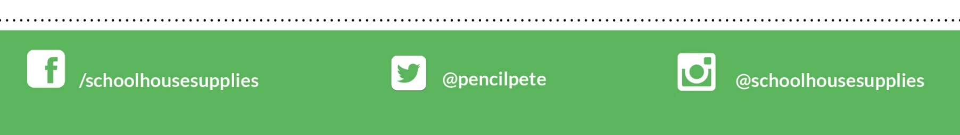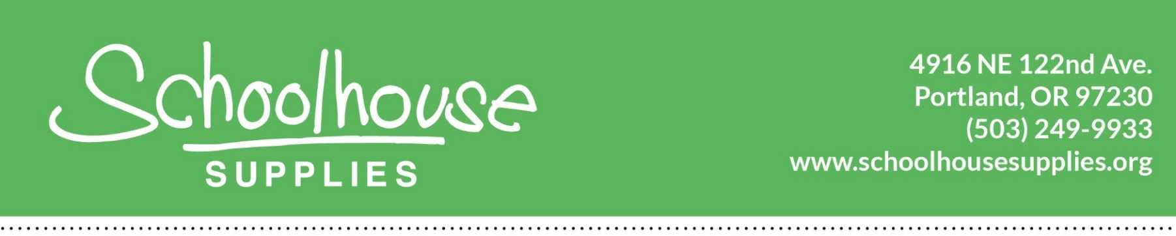

August 15, 2019

Hello!

We have great news to share with you! At the beginning of next school year, Hartley School students will receive backpacks full of school supplies through the Schoolhouse Supplies Tools for Schools Program and your school sponsor, CareOregon! Through the generosity of this partnership, every student at Hartley will receive a backpack full of supplies during the first week of school. We are thrilled with this partnership at your school!

Because of this community support, **you will not need to purchase supplies** for your child this summer, as many of the items will be provided in the backpacks!

We look forward to delivering these backpacks to Hartley on the first day of school, September 3rd!

Sincerely,

Schoolhouse Supplies and CareOregon