The Four Corners Monthly

**March 1, 2017**

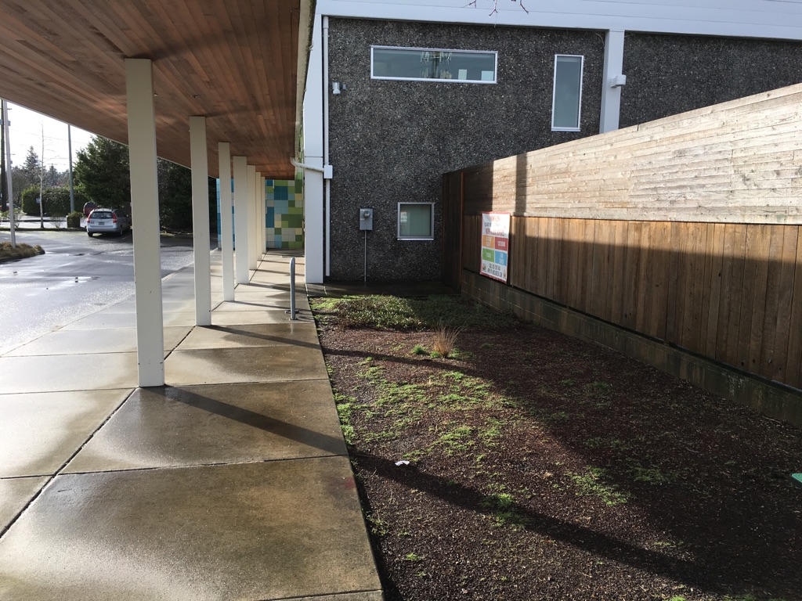

***Potential site of new Four Corners Community Garden!***

Spring, here we come!

With the holidays and snow (hopefully) now behind us, the march towards spring begins. Shrubs and trees are threatening to bloom, bulbs are daring to poke above ground, and the weather is starting to warm. Hopefully sunnier days are ahead.

Here’s what we’re looking forward to in March:   
Classrooms Eight and 10 will be getting a visit from Mad Machines for an in-school “field trip.” Students will be learning about different machines and will have an opportunity to build one of their own. Mad Machines will be at Four Corners Thursday, March 2.

Some of our middle schoolers, too, will soon be looking forward to Outdoor School. Primarily for sixth-graders, Outdoor School gives students an opportunity to learn about the natural sciences away from the urban environment. Informational letters should be going out soon for the May program.

Also in March, we’re hoping to turn a 350-square-foot plot of dirt into a community garden. We’re currently working with local nurseries for assistance, and hope to start digging in the next month.

**reminders & dates to remember**

- Parents, if you have moved recently, changed addresses or phone numbers, please let us know so we can update our contact information.

- We are in the process of designing/planning a community garden to beautify our entryway. If any families have tools they’d like to lend or donate, we’d be extremely grateful.

- There will be no school on the following days: March 15, 16 and 17 (for grading and parent/teacher conferences); 27-31 (for Spring Break)



**Congratulations, Superstars!**

The following students earned Superstar status during the month of February:

**Classroom 1-** Henry, Christian C, Madison  
**Classroom 2-** Alex, Zen, Sean, Jack  
**Classroom 4-** Thadeus, Shaun, Edgar  
**Classroom 8-** James, Tony  
**Classroom 10-** Connor M

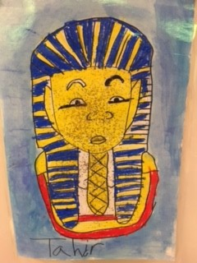

*Room 2, King Tut Mini Unit  
Art work by Tahir*

*The students read about the Boy King of Egypt and his gifts to the Egyptian people.*

**Poetic Four Corners**

Colors are colors

Hue is hue

Colors are beautiful

So are you…

*--Jacob from Classroom 4*

[Type your signature(s) as teacher(s) or aide(s).]

Staff spotlight

Meet ms. Jayme

Everyone knows that the way to one’s heart is really through their belly. It’s no wonder, then, that Jayme has kept the masses at Four Corners so happy. Nary a soul goes hungry at 4C with her in the kitchen, and the kids usually love the food options she provides. What’s more, Jayme is here bright and early getting something warm cooked up before any of the kids arrive in the morning. Her dedication is quite evident, and her hard work does not go unnoticed. From knowing kids’ special diets and food preferences, to ensuring trays are saved for the adults who may be too busy to make it to the cafeteria during lunch, Jayme is our unsung hero.

In addition to filling our bellies, though, Jayme does a lot more. In her spare time, Jayme likes to scrapbook, do photography, hike, and hang with her husband and two sons.

Jayme is also quite the singer, though nobody would know it—she does all her singing (loudly) while driving to and from work in her car. In getting to know some of Jayme’s interests, we also learned that she has seen quite a bit of the world. She’s travelled to the Bahamas, Jamaica, Hawaii and Canada. But if she could choose one place to go for an extended vacation, she’d love to tour New York City! Here’s hoping she makes it there sooner rather than later—she certainly deserves it.

