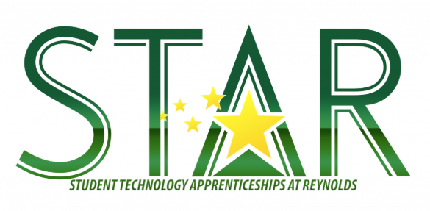

**STAR** is currently accepting **applications** for the **2019/2020** school year. If you have any students who are interested in **IT** (Information Technology), please direct them to the STAR information and application page on the Technology Services section of the school website:

[https://tinyurl.com/y2ye7ggp](https://nam03.safelinks.protection.outlook.com/?url=https%3A%2F%2Ftinyurl.com%2Fy2ye7ggp&data=02%7C01%7Cjgibbs%40rsd7.net%7C74f9891fb0304d96bb8b08d6d2fe13cd%7Cd6bfe49000f74317a5d76810ccde70fb%7C0%7C0%7C636928386025334971&sdata=m9Jb5x2UNcMPkHPi55Gah3PyYAqtZ6plmunrDyVbr%2Fc%3D&reserved=0)

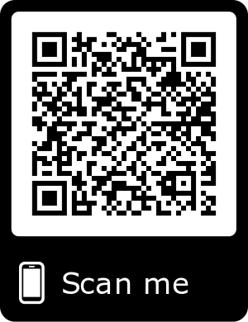

**What will you get out of STAR?**

* Work towards A+ certification (paid for by the program)
  + Industry standard certification to be a PC service technician. Many jobs are available with this certification.
* Chromebook troubleshooting
* iPad Repair
* Projector Maintenance and Repair
* Inventory
* Printer setup
* Document Camera setup
* Imaging labs with Windows and Mac software
* Wireless troubleshooting
* Soft skills/customer service
* Potential summer paid internship with Reynolds IT department