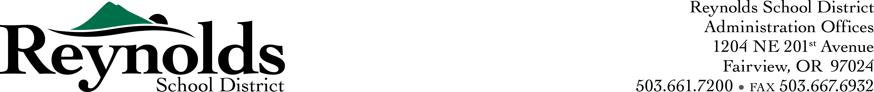
RSD Transportation Dept.
20133 NE Glisan St.
Fairview, Or. 97024
JR Rice
Head Mechanic
wrice@rsd7.net



Request For Qualified Auto Parts Suppliers

July 7, 2016

Introduction:

Reynolds School District #7 is seeking qualified Auto Parts Suppliers to provide vehicle replacement parts and shop supplies. Duration: 12 months-beginning (July 1, 2016 through June 30, 2017)

General Scope-minimums:

- The auto parts supplier shall provide online ordering to include pricing and inventory levels.
- Delivery service to our location (minimum twice per day).
- The auto parts supplier must be able to handle special orders locally and online.
- Core return credits to be done weekly.
- There is no closing date for this type of request.
- Purchase from lowest price and availability of the day.

Purchasing Process

- Reynolds School District will compare daily prices with all participating vendors before purchase.
- Will compare like for like in part quality.
- Purchase from vendor with the lowest price of the day.
- Purchase will be dependent on parts availability at the lowest price of the day.

Contact Person

J.R. Rice
20311 NE Gilsan St.
Fairview, Or. 97024
wrice@rsd7.net
503-492-4921 ext:3312

