

**How do I get more information?**

Call, text, or email the coaches:

**Jody Rash, Swimming**

541-580-6512

coachjodyrhs@gmail.com

**Dan Anderson, Water Polo**

503-888-5525

dantamara89@gmail.com

***FAQ’S***

* **How “good” do I have to be able to swim or play water polo?**

Some basic swimming skills are needed; however, we have programs available to teach you what you need to know.

* **Can I get hurt swimming or playing water polo?**

Injuries are the exception. Raider HS athletes rarely miss more than a single meet or game due to injury.

* **Can anyone swim or play middle school water polo?**

Yes! Boys and girls can swim & play water polo in middle school. Even students who don’t attend a Reynolds District school can be involved!

* **Do I have to wear a “speedo”?**

No. Guys do not need to wear a “speedo”-style suit.

Girls DO need to wear a one-piece suit.

* **When does middle school swimming & water polo start?**

We will have two, 5-week sessions, starting March 2, 2015.

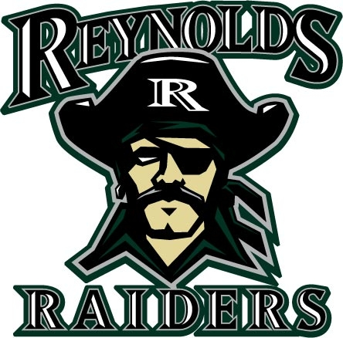

**Middle**

**School**

**Swimming**

**&**

**Water Polo**

***Our Mission:***

**Raider swimming & water polo**

**will be the premier**

**Eastside aquatics programs, contending for state championships within a team culture of**

**positive character & excellence**

***Ages, Dates, Times & Fees***

* **MS Swimming & Water Polo are available for students currently enrolled in 5th – 8th grades**
* **Session I:**

**March 2 – April 9\***

**\*No practices Spring Break**

* **Session II: April 20 – May 21**
* **Swimming: Monday & Wednesday 3:45 – 5:15 pm**
* **Water Polo: Tuesday & Thursday 3:45 – 5:15 pm**
* **$50 per 5-week session: Swimming - *OR* - Water Polo**
* ***$80 per 5-week session: Both Sports!* Swimming - *AND* - Water Polo**

***Our Values***

* **Get better every day.**
* All business in practice.
* Become better human beings.
* Play the game the right way.
* Be a community that is attractive to other people.

***Why Swim?***

***Why Play Water Polo?***

* **They are great cross training for nearly any other sport.**
* **It is not necessary to have been on swim team or played water polo in grade school to be a great player in middle school and high school.**
* **You will be a part of one of the largest middle school swimming & water polo programs in the state of Oregon.**
* **Swimming & Water Polo are a blast!**

***What our athletes learn from swimming & water polo:***

I have learned to never give up and to make the best of whatever I have.

How to keep going even after a loss.

Being dedicated.

I’ve learned to positive and not gossip.

I’ve learned the importance of friendship - friends will last.

I learned time management.

To manage my time better and to work with my teammates.

Not to judge others.

Two things I learned was teamwork and how to forgive and forget

I learned in order to get better you need to push through the tough times.

How to be a leader.

How to be a friend

It’s okay to be myself.

Sometimes you just have to make the best of what you have.

How to be a better teammate.

To give it your best and not give up, even though it is hard.

Winning feels good

***Why play polo?***

1. **It is great cross training for nearly any sport.**
2. **It is not necessary to have played years of water polo in grade school to be a great player in middle and high school.**
3. **You will be part of the largest middle school water polo program in the state of Oregon.**
4. **Water polo is a blast!**

**1st Team MHC All-Star, Morgan Mattice, 2013**

***Our Values:***

1. Gt better every day.

human beings.

4. Play the game the right way.

5. Be a community that is attractive to other people.

1st Team MHC All-Star, Cameron Ross, 2013