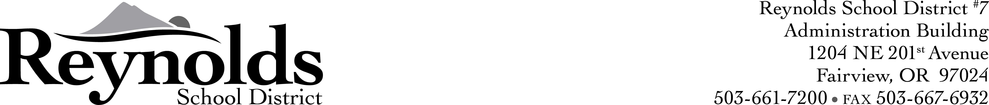

2014-2015 BUDGET COMMITTEE APPLICATION
Reynolds School District

TO: Candidates for the Reynolds School District Budget Committee

The following application is designed to help the Board of Education learn more about you and your desire to serve on the Budget Committee.

Name _____________________ Phone (H) _______________________

Address _____________________ Phone (W) _______________________

City/Zip _____________________ Phone (C) _______________________

1. Are you a registered voter in Reynolds School District? Yes No

2. Have you been a District resident for at least one year? Yes No

3. Why are you interested in serving on the Budget Committee?

4. Have you served in similar capacities in the past and, if so, under what circumstances?

5. Please describe your understanding of the time commitment required of a Budget Committee member.

6. Please provide us with a brief resume of your background and your activities in the community.

Note: This application should be returned by October 21, 2014 to the attention of Connie Philibert, Board Secretary, Reynolds School District, 1204 NE 201st Avenue, Fairview, OR 97024 or email cphilibert@rsd7.net.


Interviews will be conducted at the October 22, 2014 Board Work Session at Reynolds Middle School – Room 203 beginning at 6:00pm. Please plan on attending this Work Session. The Board will appoint the three budget committee positions at the November 12, 2014 Business Meeting, 7pm, Fairview City Hall.

