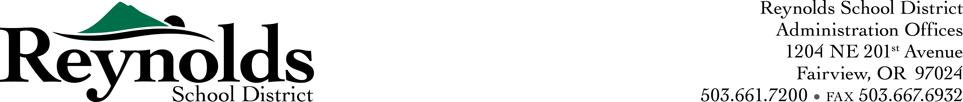

Request for Proposal - Quotation

June 20, 2019

Introduction:

Reynolds School District is seeking quotes for a USED forklift.
General Scope-Minimums

- Must have a LP engine.
- Must have 4 pneumatic tires.
- 5000 to 10000 lift capacity.
- 2 stage mast.
- Side Shift.
6. 48-inch fork length.
7. Forks need to be adjustable.
8. Must include delivery.
9. Forklift certification training for 5 techs.

Award Process

- Reynolds School District will review all quotes to determine the best valve for the district.
- Review available services as listed in the general scope.

Quotes must be submitted by 07/20/2019 by 1500.

Contact Person

J.R. Rice
Lead Mechanic
20311 NE. Glisan
Fairview, Or. 97024
wrice@rsd7.net
503-492-4921 ext.: 3312

