***DAVIS Book Mobile!!!***



The Davis Book Mobile will be coming to you on ***Tuesdays*** this summer!!!! *Get books and a lunch this summer near you! ☺*

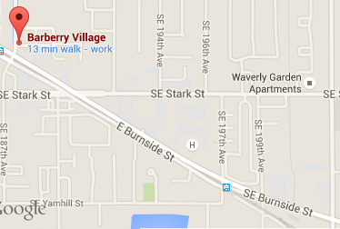

|  |  |
| --- | --- |
| ***Rockwood Landing:***  (by the playground)  11:45 am-12:15 pm | ***Barberry Village:***  12:30-1:00 pm |

***Dates:***

June 27th

July 11th

July 18th

July 25th

August 1st

August 8th

August 15th