

Davis Monthly Newsletter

January/February 2018

SAVE THE DATE!



***Who:*** Davis Families

***What:*** OMSI Science Night and Pizza at Davis

***Where:*** Davis Cafeteria

***When:*** Thursday, January 25th from 4:30-7:30 PM

***Why:*** To have fun and explore science as a Davis community!

**Did you know we have a morning SUN session? We still have spots available!**

Monday: 8:30 am - 9:30 am

Tuesday-Thursday: 7:30 am -8:30 am

*Contact Kevin Donato our SUN Site manager for more information.*

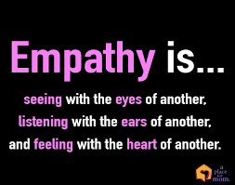

Hello Davis Friends and Families-

Welcome to 2018! We have gotten off to a strong start to 2018 at Davis. This month students have been learning about perspective. In February, we will be focusing on learning about “joy and happiness.” Each week your child receives instruction around mindfulness and their brain. Ask them what they are learning in MindUP in their classrooms.

In order to continue to provide supports for social and emotional learning at Davis, we have started using a curriculum called Kimochis. This curriculum supports students in learning about feelings, communication skills, and so much more. Be on the lookout for parent information sessions coming soon!

**A friendly reminder that our dismissal time is 3:20**. Many parents are coming in early to pick up students, which is distracting to our teachers teaching. Your child is receiving instruction until the end of the day. It is important that students miss as little instructional time as possible. Please make sure you are only picking up students early if they need to leave for something that cannot be done outside of school hours.

It is very important that we have the most up-to-date phone numbers in order to get a hold of you. Please make sure you let the office know if we need to update your information.

Attached is a calendar of events.

GO DRAGONS!

Ms. Furlong

Principal