SUN Community School at Woodland Elementary
Dear Woodland Families,
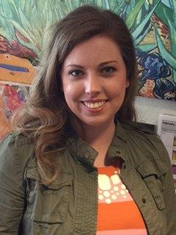
Welcome back! I have had the pleasure of meeting many of you in the past, but if we have not yet met, my name is Tina Moe and I’m the new SUN Community School Site Manager here at Woodland Elementary. Over the past two years in my role as the SUN Site Assistant, I have had a chance to get to know many of you and have learned so much about the Woodland community. Thank you to the many families who have made me feel welcomed, participated in SUN events, volunteered time, or provided input. You have truly helped us to grow as a SUN school!
For our new families joining us, SUN (which stands for Schools Uniting Neighborhoods) may sound like just another program, but it’s really a strategy where the school community and partners from across the broader community come together to create a collective impact to educate and support our students and families.
Over the course of the year, I am committed to bringing new and exciting activities and partners into the school. If you, a family member or friend would like to volunteer your time to teach an activity class, assist with a class, tutor, help with events, etc. or you know of an organization that would like to partner with our school just let me know! I can easily be reached here at school 503-674-8188 x1533, on my cell 503-839-3499 (I am text friendly too), by email Tina@latnet.org, and of course in person. Thank you and I look forward to continuing the legacy that has been set before me.

Here’s to a great year at Woodland!
