How To Use Spell Check with Outlook 365 Web Client on a Mac using Firefox
- Make sure Spell Check is enabled in Firefox. Open Firefox and click Firefox > Preferences
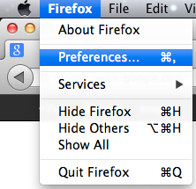

- Click the Advanced button and Select Check my spelling as I type and Close the window
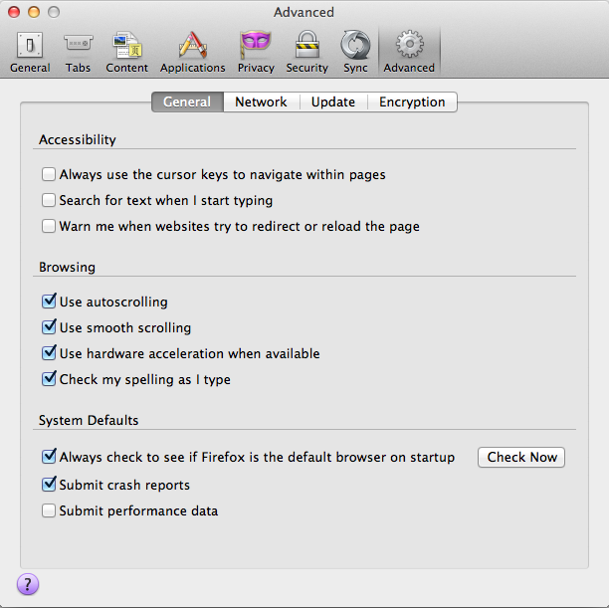

- When typing a message right click or control+click the misspelled word for suggestions
