HOW TO OPEN PDF FILES IN FIREFOX WITH OFFICE 365 – OUTLOOK WEB

Currently Microsoft has disabled the ‘WebReady Document Viewing’ feature in the Office 365 Outlook Web Client which blocks the ability to view PDF files in your internet browser. Microsoft is working on a fix to re-enable this feature but until then you will need to download the PDF files to your computer to open them. Below are the instructions to open a PDF file in Firefox.

- Open the email message and you will see the PDF attachment in the message at the top. Highlighted in Red.

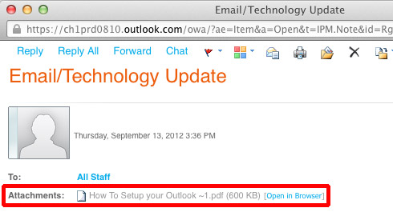

- To open the Attachment click Open in Browser.

- Right Click on the Attachment in blue and select Save Link As. If you don’t have a Right Click option hold down the Control Key and click the Attachment in blue.

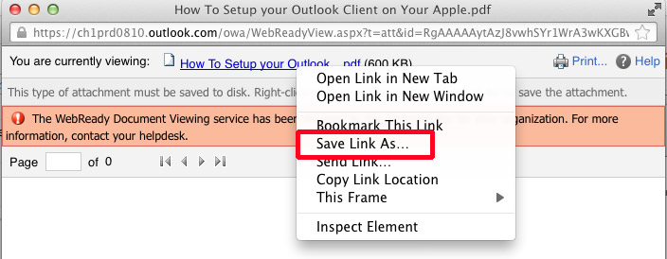

- Save the attachment to a location on your computer. A common place is your desktop.

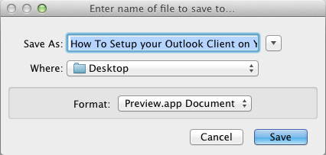

- Once the attachment has been saved you will see a Downloads window. Double Click the file to Open it.

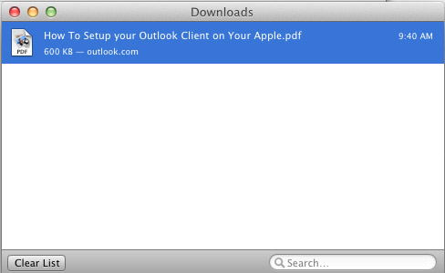

- If you do not see the Downloads window you can open the file from your Desktop. Minimize your Outlook Web Client and the file will be on your Desktop.

