How To Change an Email Password
By: Corby Bennett of Tech Heads Inc. 11/8/2012

Table of Contents
Change your password 2
Login to Outlook Web Access 2
If your password has expired 2
If your password has not expired 2
Update saved credentials in Outlook 3
Update the Password in Outlook for Windows 3
Update the Password in Outlook for Mac 4

Change your password

Login to Outlook Web Access
- Open a web browser and navigate to http://mail.rsd7.net/
- Login to the site using your email address as your User ID

If your password has expired
If your password has already expired you will be prompted to update your password immediately after logging in as shown below.
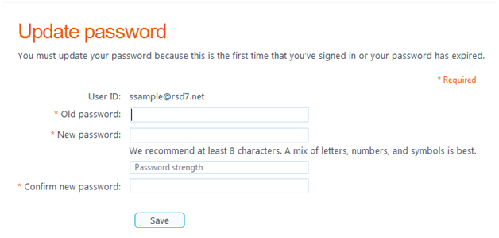
- Enter your old and new passwords in the appropriate fields
- Click Save to continue

If your password has not expired
Follow the instructions in this section only if you would like to preemptively change your password.
If your password has not yet expired you will not be prompted to change it after logging in to Outlook Web Access. To change your password after logging into the Outlook Web Access:
- Click on Options -> See all options in the top right hand corner of the web page
- Click Change your password
- Enter your old and new passwords in the appropriate fields
- Click Save to continue

Update saved credentials in Outlook
After changing your password in Outlook Web Access, you will need to update your password all of your mail clients. This process will need to be done on every PC, Mac, or phone that you use for email. Failure to do so will result in an account lockout due to too many failed login attempts.
Note: Prompts and dialogues may appear slightly different between versions of Outlook, however the process should be very similar.

Update the Password in Outlook for Windows
- If your Outlook client is already open, close it
- Launch Outlook
- You should be prompted for a password as shown below
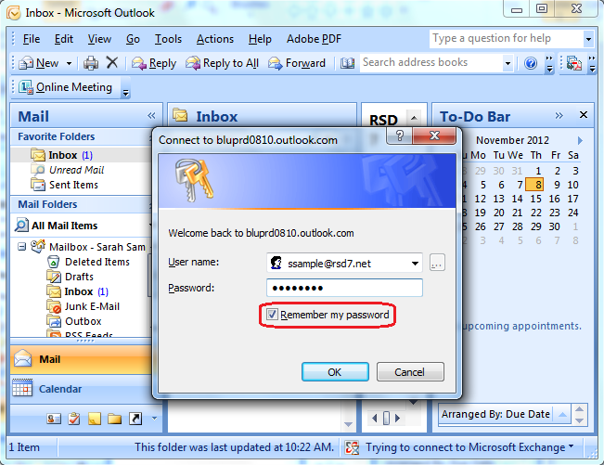
- Enter your new password
- Check the box next to Remember my password
- Click OK

Update the Password in Outlook for Mac
- If your Outlook client is already open, close it by holding the Ctrl key and clicking on the Outlook icon in the dock and clicking Quit
- Launch Outlook
- You should receive an error asking if you would like to re-enter your password as seen below
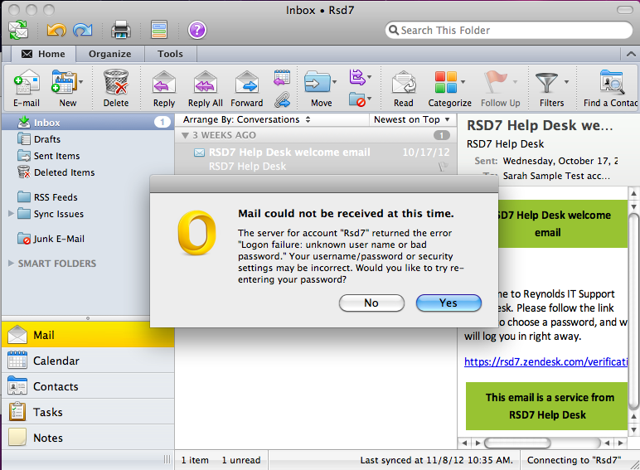
- Click Yes
- You will be prompted for a password as shown below
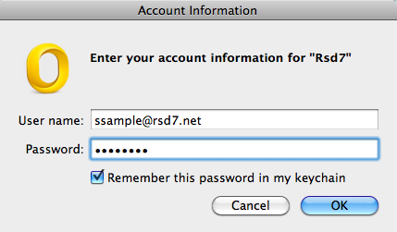
- Enter your new password
- Check the box next to Remember this password in my keychain
- Click OK

